**MovieTime - Movie Ticketing System**

MovieTime is A System for Booking Cancelling Movie Tickets.

**1. Home Screen**

Book ticket - Button

or

Cancel ticket- Button

or

View Reports Button

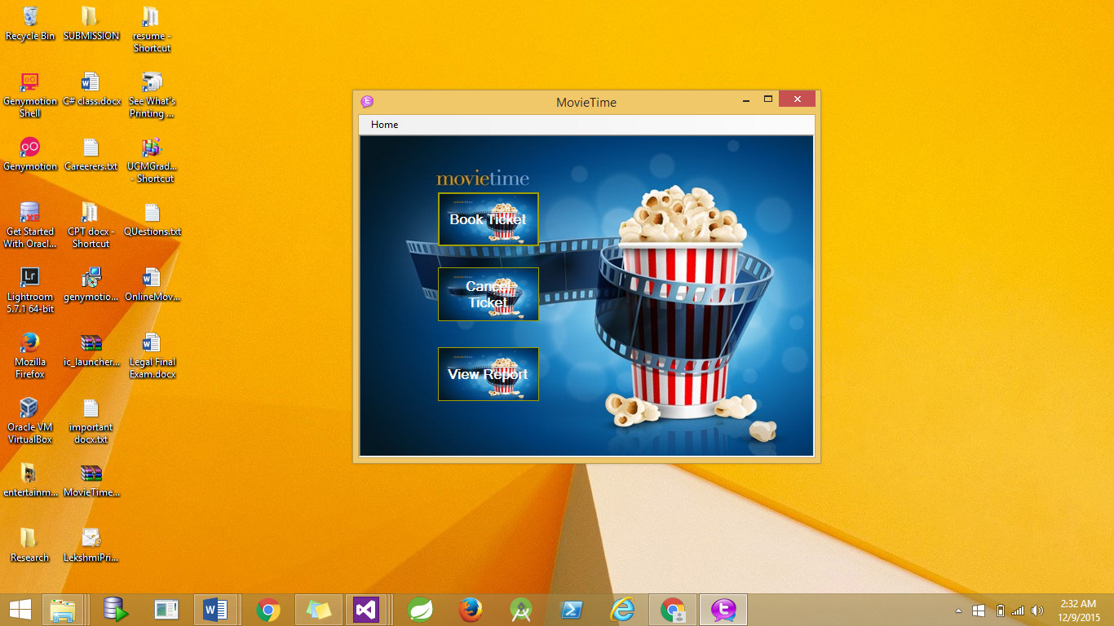

**2. Search Movie/Book Ticket (Layout):**

User can search either with a

Movie Name - Text Box

or Date -Date Picker

or Language - Text Box

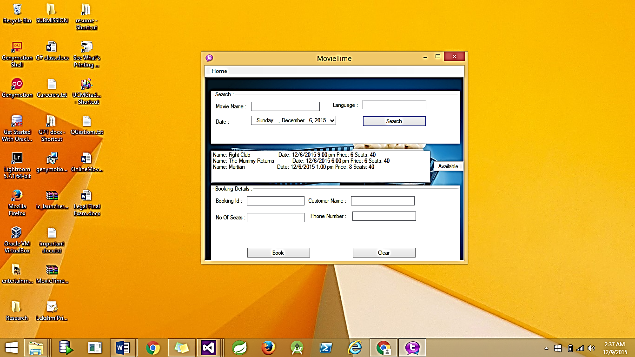

Search Button( movie table)

Listbox with results of search,

Available Button- Filters and shows only movies which are not full [LINQ implementation]

User picks only the desired row

Movie Name, Showtime,Date,Language

User is prompted to enter further details

CustomerName - Textbox

Phone - Text Box

Booking Summary Shown before Booking

After which user clicks the Book button

A booking Id is auto generated for the above values( Movie name, cust name, show time, #of seats, price)

**3. Cancel Form:**

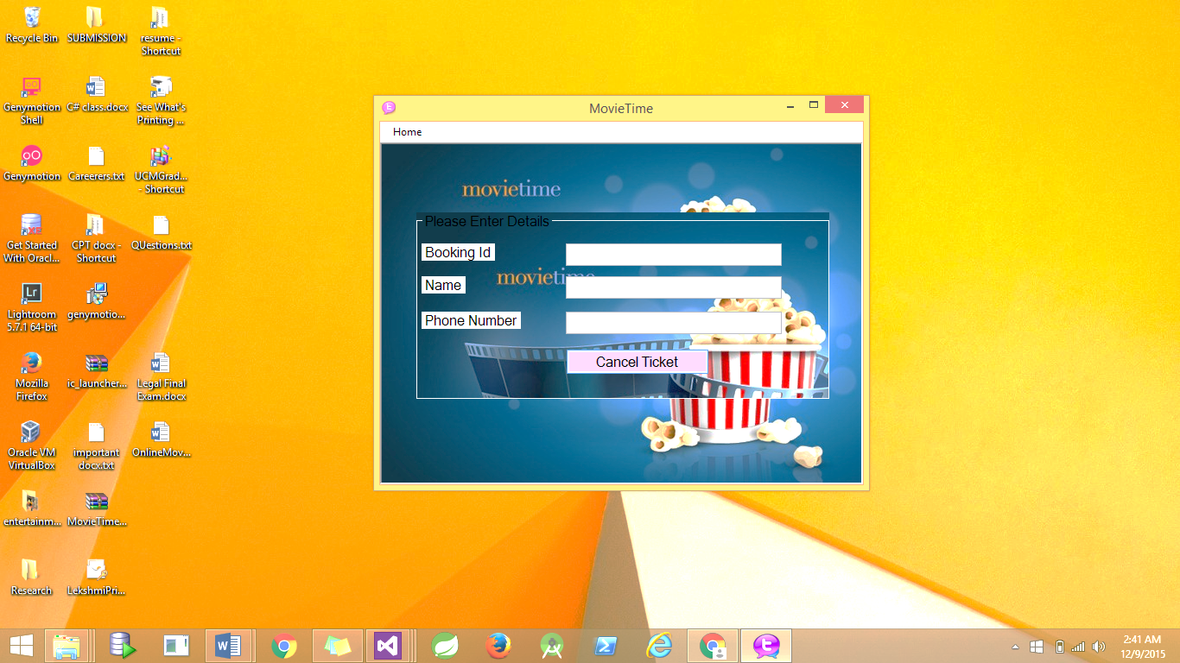

User can enter

Phone number - Text Box

or

Booking Id - Text Box

or

Customer name - Text Box in the booking table

Confirmation Box with order Details (booking id, movie name, cust name, price, #seats) are displayed . Click confirm to cancel the booking.

Clicks cancel button to cancel the booking.

**4. View Report**

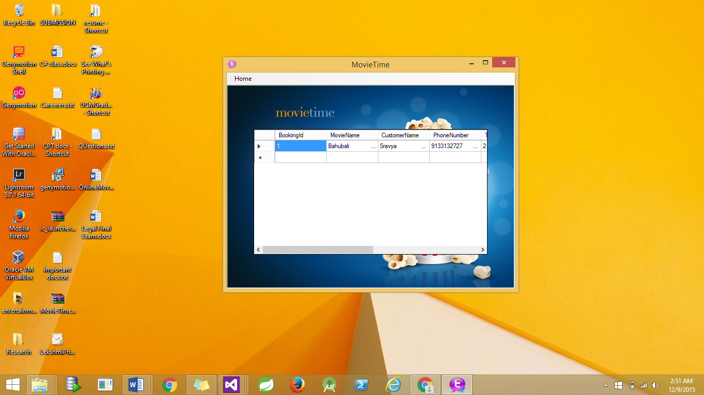

Tables:

Booking ( booking Id, moviename, cust name,phone #, total # seats, date, showtime, total price)

Movie ( movie id, name , date, showtime,language, price, no of seats)

Classes:

1) IBooking - Interface

Methods: CalculatePrice()

2) Booking - Implementation of interface

Attributes: BookingId, moviename, cust name,phone #, total # seats, date, showtime, total price

Methods: CalculatePrice()

ToString();

3) Entertainment Class - Parent Class

Attribute:Type(movie or sports)

date

showtime

price

no of seats

Methods: UpdateNoOfSeats()

ToString();

4) Movie Class - Child Class

Attribute: movieId

movieName

language

Method: ToString();

5) BookingList Class - Generic Class(which contains a list of all bookings(IEnumerator))

Attribute: List<T> BookingList

Methods: AddBooking(booking object)

GetEnumerator()